What is a GUI Application?
A GUI (Graphical User Interface) application is a type of software that allows users to interact with it through graphical elements like:
- Windows
- Buttons
- Text boxes
- Labels
- Menus
- Checkboxes, etc.
Unlike CLI (Command Line Interface) applications, where users must type commands, GUI applications provide a visual and interactive experience.

What is Tkinter?
Tkinter is the standard GUI library for Python. It is built-in, so you don’t need to install it separately. Tkinter is a wrapper around Tcl/Tk GUI toolkit, which is a platform-independent GUI library.
Tkinter is included with Python distributions (e.g., CPython), so it's ready to use.

Why Tkinter?
Here are some reasons why Tkinter is widely used for GUI development in Python:
Feature | Reason
Built-in | No need for external installation
Simple | Easy syntax and beginner-friendly
Cross-platform | Works on Windows, macOS, and Linux
Lightweight | Good for simple and medium-complexity apps
Extensible | Can integrate with other libraries easily

Structure of a Tkinter Application
A basic Tkinter app has:
- Main Window – the main GUI window.
- Widgets – GUI components like labels, buttons, text boxes.
- Geometry Manager – to arrange widgets (pack, grid, place).
- Mainloop – an infinite loop to keep the GUI running.

Common Tkinter Widgets
Widget | Description
Label | Displays text or images
Button | Creates a clickable button
Entry | Single-line text input
Text | Multi-line text input
Checkbutton | Checkbox
Radiobutton | Multiple-choice options
Listbox | List of items
Canvas | Drawing shapes and graphics
Menu | Menus and submenus
Frame | Container for other widgets

Layout Managers in Tkinter
Method | Description
pack() | Packs widgets vertically or horizontally
grid() | Places widgets in table-like structure
place() | Absolute positioning using x/y coordinates
grid() is good for forms, pack() is quick for simple layouts.
EX1:
Write a python program to create a GUI window?
demo.py
import tkinter
window=tkinter.Tk()
#write your logic here
window.mainloop()
output
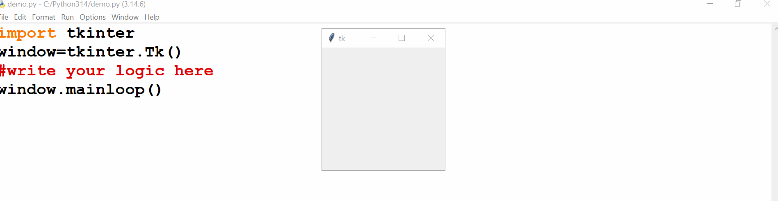
Example2:
Write a python program to create GUI window with specific size?
demo.py
import tkinter
window=tkinter.Tk()
window.geometry("500x400")
window.mainloop()
output
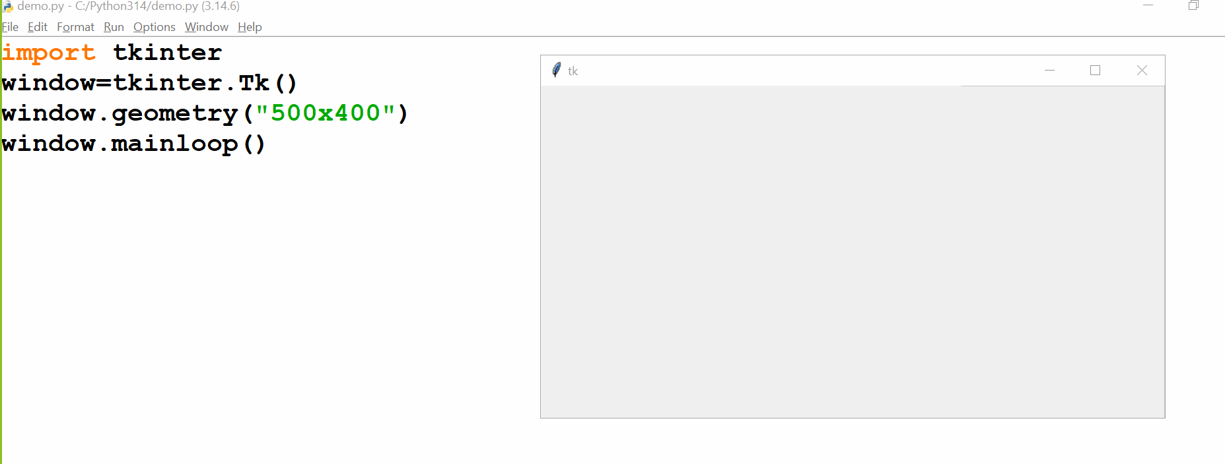
Example3:
Write a python program to create GUI window with fixed size?
demo.py
import tkinter
window=tkinter.Tk()
window.geometry("500x400")
window.resizable(0,0) #window.resizable(False,False)
window.mainloop()
output
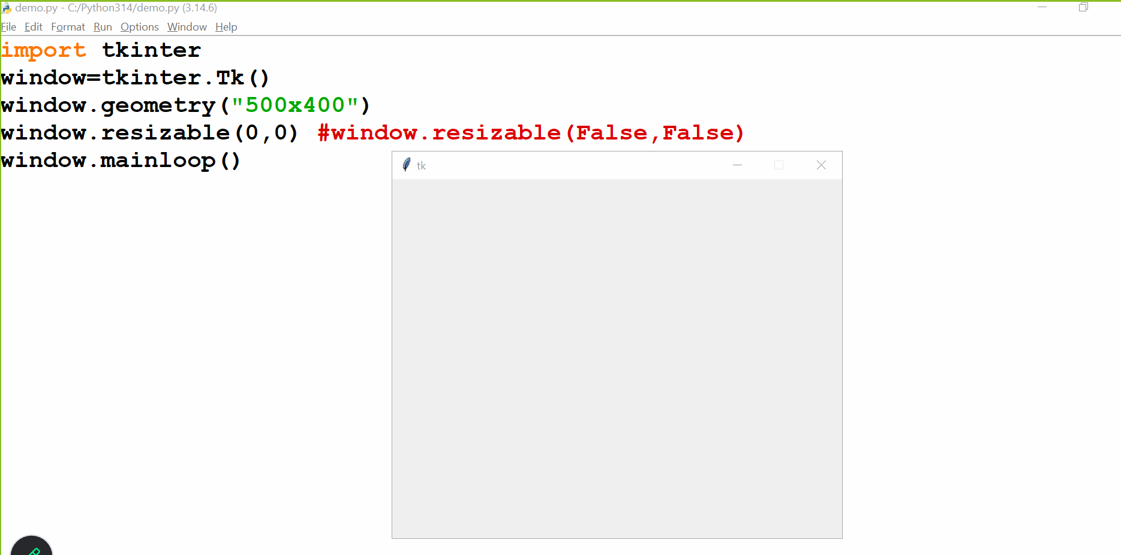
Example4:
Write a python program to create a GUI window with custom title?
demo.py
import tkinter
window=tkinter.Tk()
window.geometry("500x400")
window.resizable(0,0)
window.title("Vagdevi Technologies")
window.mainloop()
output
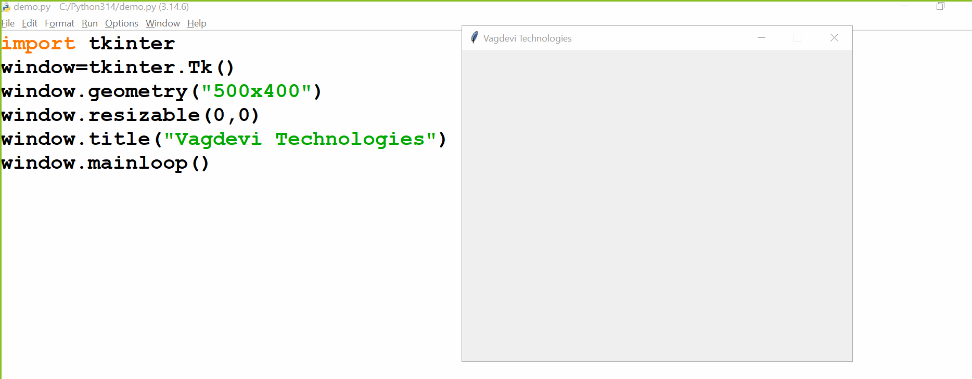
Example5:
Write a python program to create a GUI window with custom logo?
Step1: to convert our images like .png,.jpeg,.jpg into .ico
Step2: to add that file into our script
demo.py
import tkinter
window=tkinter.Tk()
window.geometry("500x400")
window.resizable(0,0)
window.title("Vagdevi Technologies")
window.iconbitmap("pytlogo.ico")
window.mainloop()
output
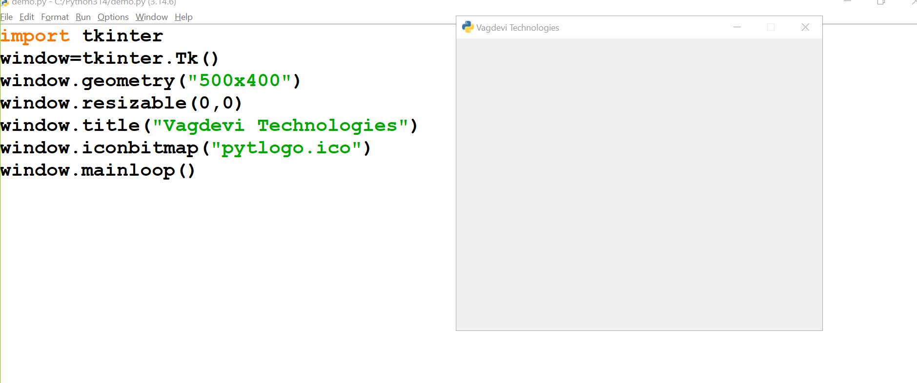
Example6:
Write a python program to create a GUI window with background color?
demo.py
import tkinter
window=tkinter.Tk()
window.geometry("500x400")
window.resizable(0,0)
window.title("Vagdevi Technologies")
window.iconbitmap("pytlogo.ico")
window['bg']="red"
window.mainloop()
output
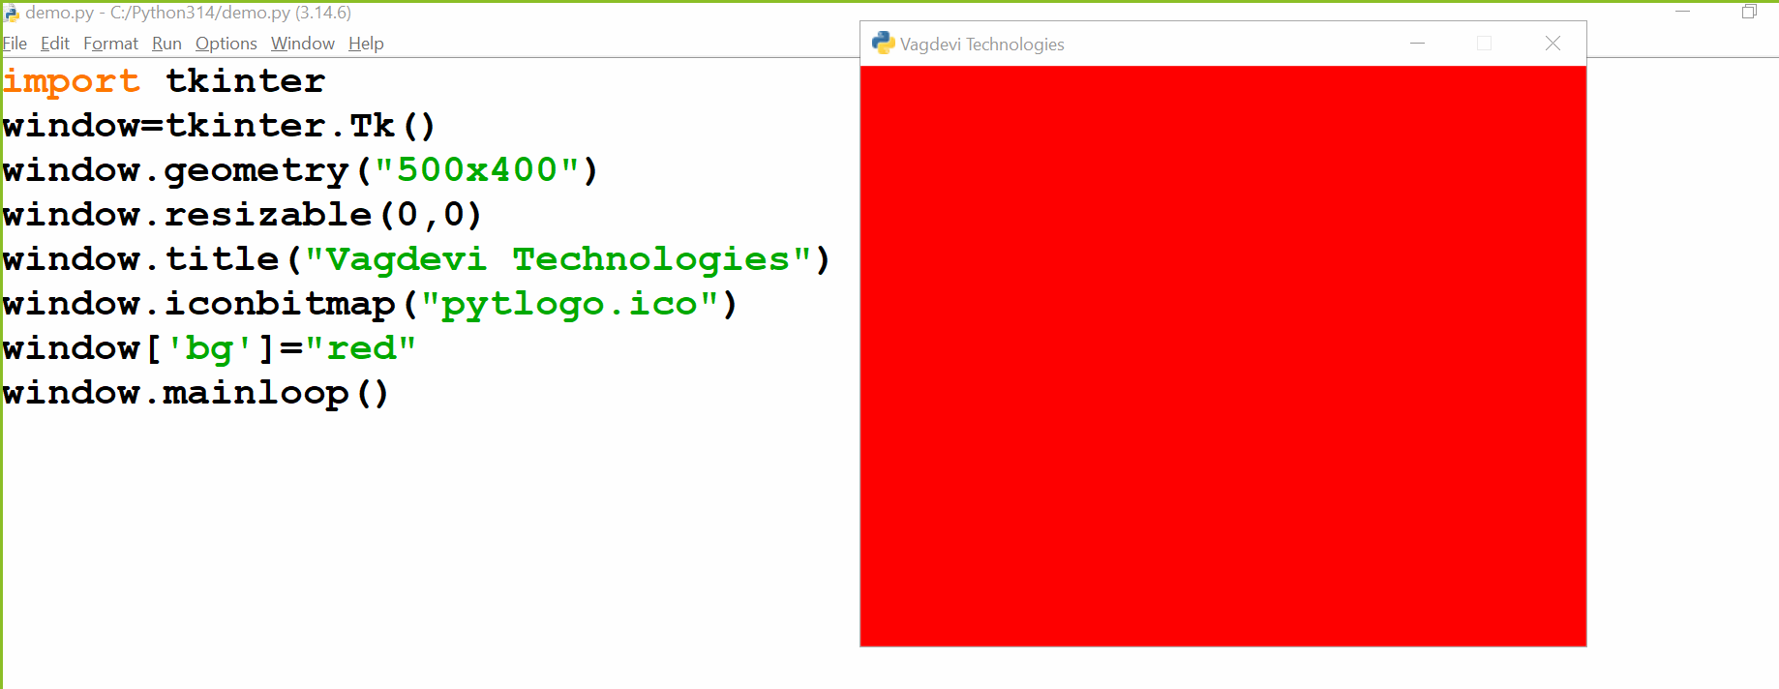
Example7:
Write a python program to create a GUI window with Label?
demo.py
from tkinter import *
window=Tk()
window.geometry("500x400")
window.resizable(0,0)
window.title("Vagdevi Technologies")
window.iconbitmap("pytlogo.ico")
window['bg']="red"
L1=Label(window, text="Welcome to Vagdevi Technologies")
L1.pack()
window.mainloop()
output
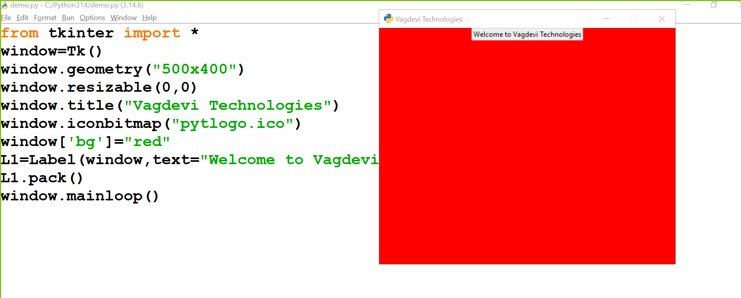
Example8:
Write a python program to create a GUI window with multiple Labels?
demo.py
from tkinter import *
window=Tk()
window.geometry("800x400")
window.resizable(0,0)
window.title("Vagdevi Technologies")
window.iconbitmap("pytlogo.ico")
window['bg']="red"
L1=Label(window,text="Welcome to Vagdevi Technologies")
L1.pack() #side="top"
L2=Label(window,text="Welcome to Vagdevi Technologies",bg="yellow")
L2.pack(side="left")
L3=Label(window,text="Welcome to Vagdevi Technologies",bg="yellow",fg="blue")
L3.pack(side="right")
L4=Label(window,text="Welcome to Vagdevi Technologies",bg="yellow",fg="blue",
font=("arial",15,"italic"))
L4.pack(side="bottom")

window.mainloop()
output
